*Florida International University*

*School of Computing and Information Sciences*

CIS 4911 - Senior Capstone Project

Software Engineering Focus

Feature Document

User Story #550

**Team Member:**

Andrew Mitchell

**Product Owner(s)**:

Francisco R. Ortega

**Mentor(s)**:

Francisco R. Ortega

...

**Instructor**: Masoud Sadjadi

# **User Story** – Implement Layers

* As a User I would like to have multiple layers to draw on so that I can edit a single layer at a time.

## **Use Case – Layer Menu Button**

Use Case

Create a way to layer drawings.

Details:

Actor: User

Pre-conditions:

Touch screen working.

Program Running.

Swap layers ‘l’

Description:

Use case begins when a user presses a key (‘l’, Temporary until design philosophy is completed). This will alter the touch screen to draw lines on the other layer (currently 2 layers are implemented).The user story ends when the user successfully draws a line on a specific layer and lets go. If the user changes layers, the lines move to the ‘background’ of the other layer.

Post-conditions:

Lines will be drawn on the touchscreen

If one layer is above another, the lines will be drawn on top, while the other layer will be ‘below’ it.

Decision Support:

Frequency: Moderate.Using multiple layers is useful when sketching on one layer to draw properly on the higher layer.

Criticality: Low. Enables more ways to paint on the canvas, and allows for more flexibility when creating a piece of art.

Risk: High. Need to learn about how layering works. Implement Framebuffer objects, and learn about computer graphics to a higher degree.

Usability:

Just need to learn the proper keybinding.

Reliability: Very Reliable.

Mean time to Failure – Should only fail in extreme conditions. (Keyboard input overloads etc).

Availability – Always available (may change at a future date).

Performance:

Should switch layers simply as well as redraw the layer which is on top right away.

Supportability:

Must work with ACER Multitouch.

Modification History:

Owner: Andrew Mitchell

Initiation date: 02/10/2016

Date last modified: 02/14/2016

## 

## **Use Case Diagram**

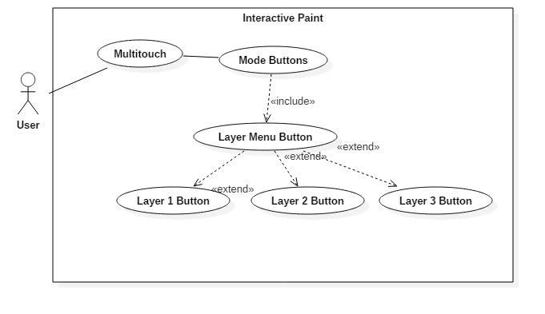

## **Sequence Diagram**

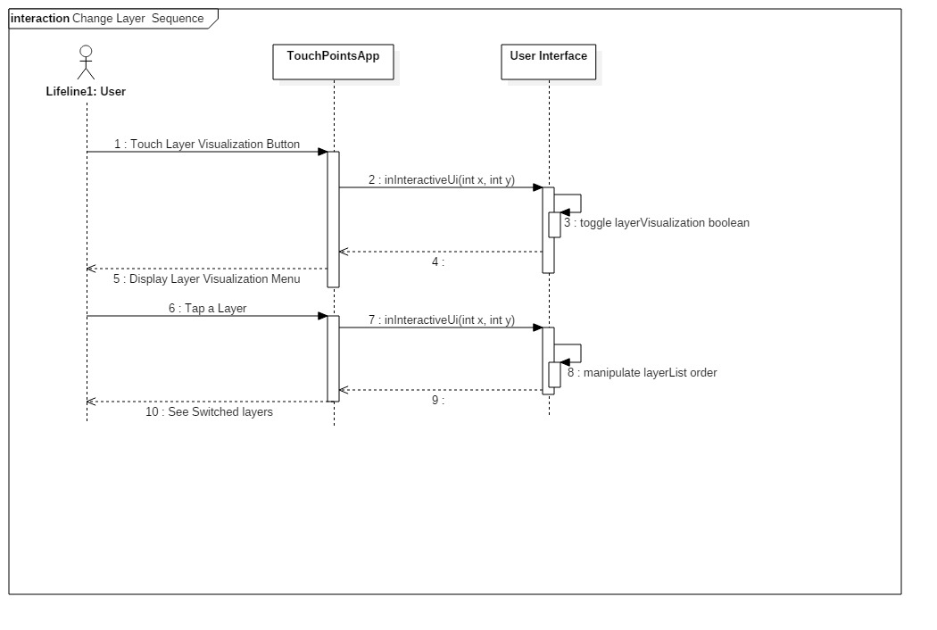

## 

## **Class Diagram**

## C:\Users\IEatR\Pictures\ChangeLayer Class.png

## **Unit Test**

Sunny Day Tests

Test Case: Change Layers

Test Purpose:

Ensure each layer is separated.

Test Setup:

1. Change to filled circles
2. Draw a circle
3. Change color to red
4. Open layer menu
5. Press second layer
6. Draw a red circle on top of your black circle
7. Press the original layer

Test Output:

After drawing the red circle it was on top of the black circle. When we pressed the layer with the ‘black’ circle it then was on top.

Expected Output:

After drawing a red circle it should be on top. When you swap layers, the black circle should be on top.

Rainy Day Tests

Test Case: Swapping layers

Test Purpose:

Make sure we switch to the proper layer.

Test Setup:

1. Draw a filled Red circle
2. Change to an empty layer
3. Draw a blue circle that overlaps with the red circle
4. Change to an empty layer
5. Draw a Green circle that overlaps with both the red and blue circle.
6. Change to layer with Red circle
7. Change to layer with blue circle
8. Change to layer with green circle.

Test Output:

When I changed to red circle layer, the red moved to the top.

When I changed to blue circle layer, the blue circle moved to the top.

When I changed to the green circle layer, the green circle moved to the top.

Expected Output:

Whichever layer you select, the layer with that specific color should be on top.

## **Integration Test**

Currently works with all shapes and color drawings.

Currently works with all alpha implementation as well.

Layers currently support the eraser functionality as well.

## 

## **User Guide**

Use the layer visualization menu to change layers, indicated by the green arrow.

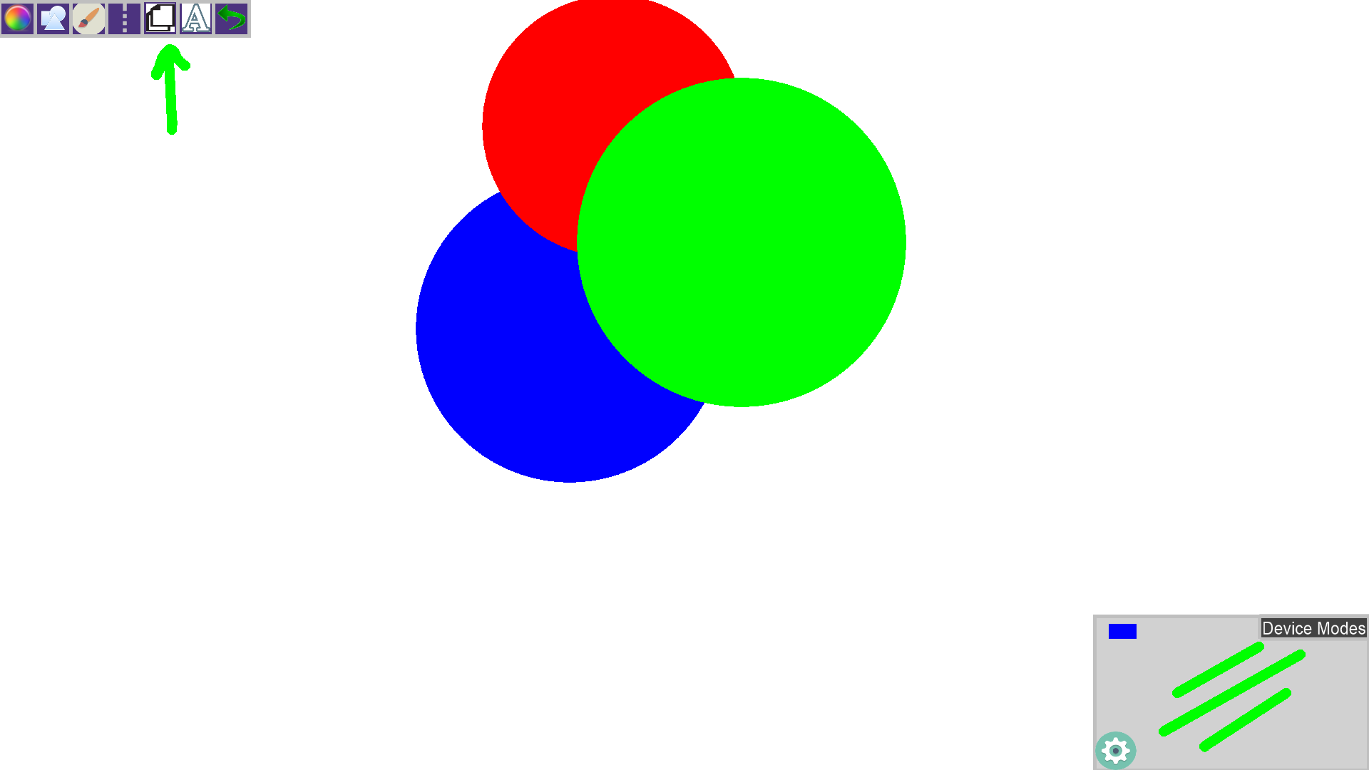

Tap the example canvas of your layer to change to that specific layer!

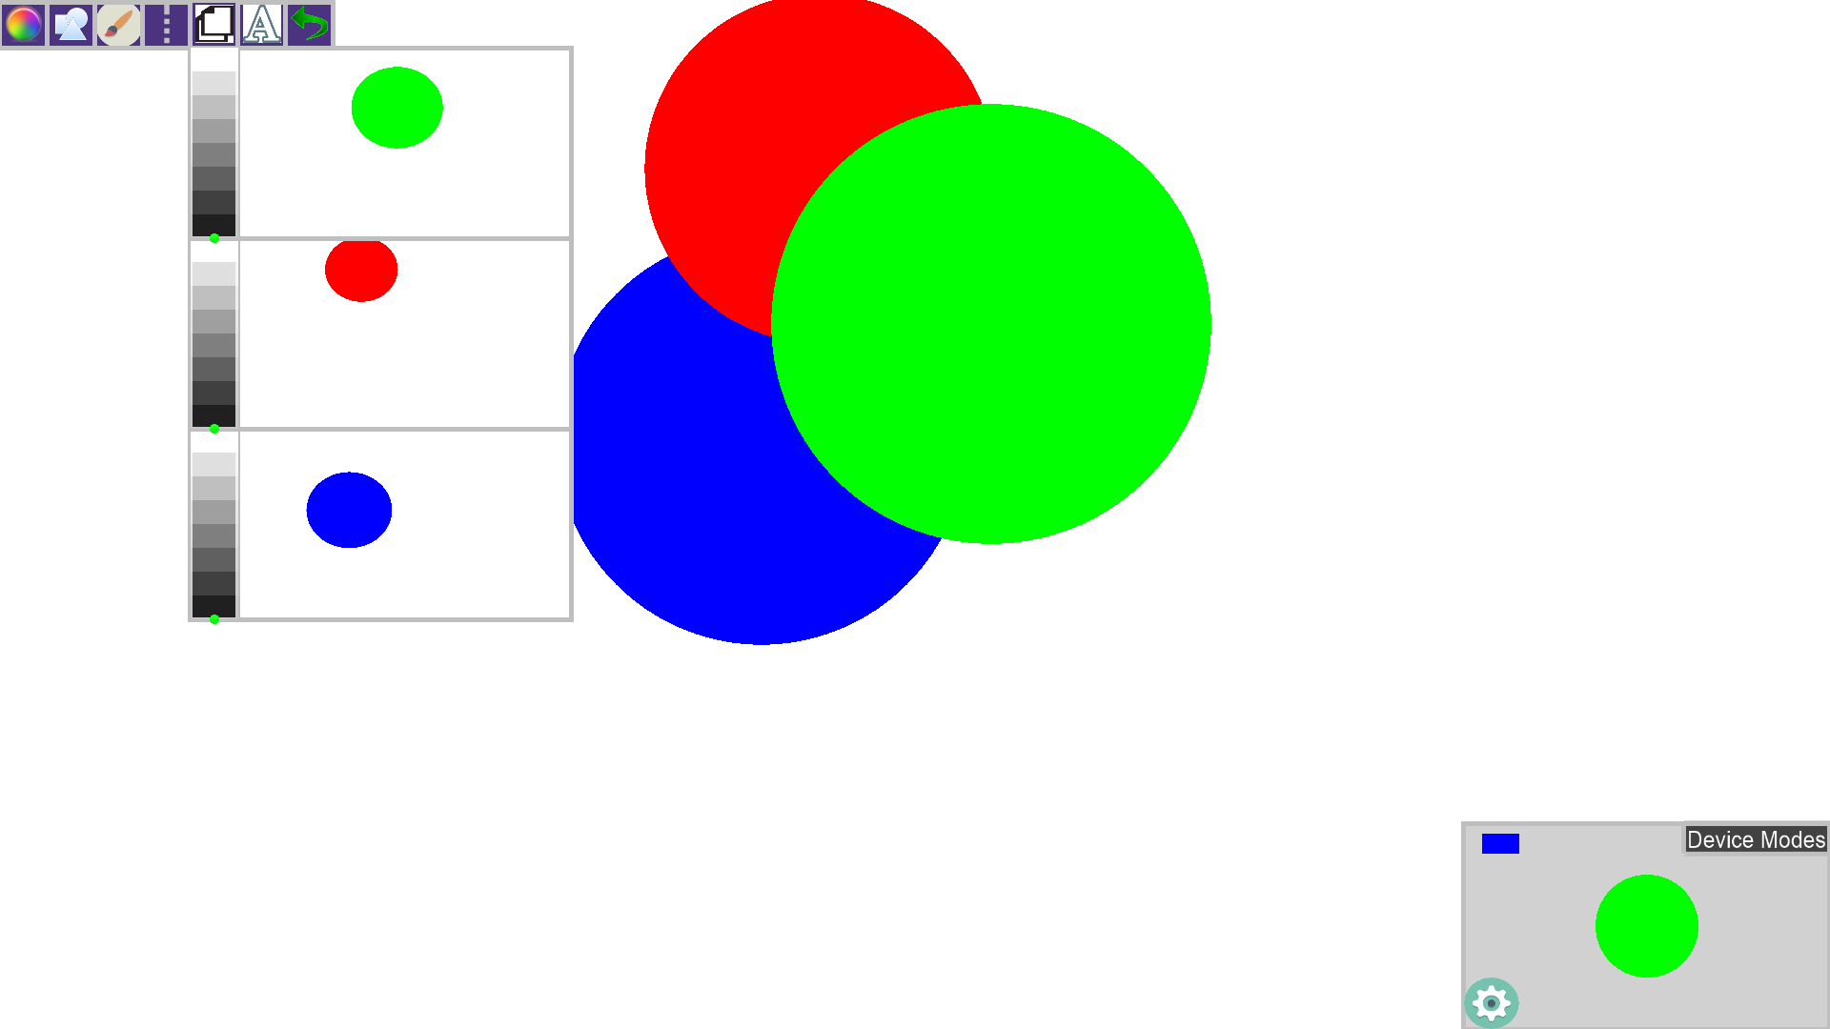

We can see the layers correspond to the order which the circles are placed. The green circle is at the ‘top’ of the list, and is drawn on top of the red and blue circles. While the red, the second layer, is drawn on top of the blue circle!

**Glossary**

Layers – Individual pieces of our canvas. You can draw an image on a specific canvas, and then move one canvas on top of another so we change the order in which we draw our image.